**Application Review**

**1. Fulcrum** 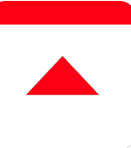

<https://play.google.com/store/apps/details?id=com.spatialnetworks.fulcrum>

**General Overview and Starting *Fulcrum***

Fulcrum is a hosted mobile forms platform that allows user to build their own data collection form by using existing ‘applications’ to capture the specialised data they desire (seen on the right photo).

When the user wants to collect their data, they are first prompted to the ‘Add App’ page, this is where the user chooses their field (agriculture, construction, GIS, etc.) to gather the most relevant information.

After user specifies the field, then they are displayed with more advanced features (shown in the image below), and all the user needs to do, is click on the application and it will automatically install and be ready to use.

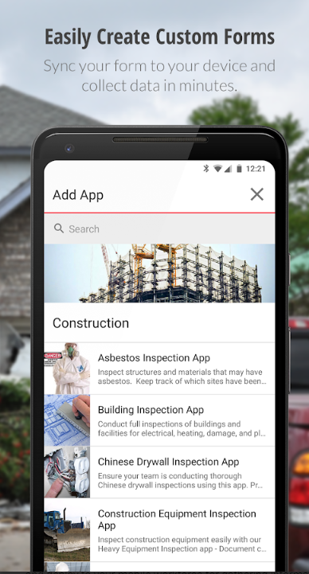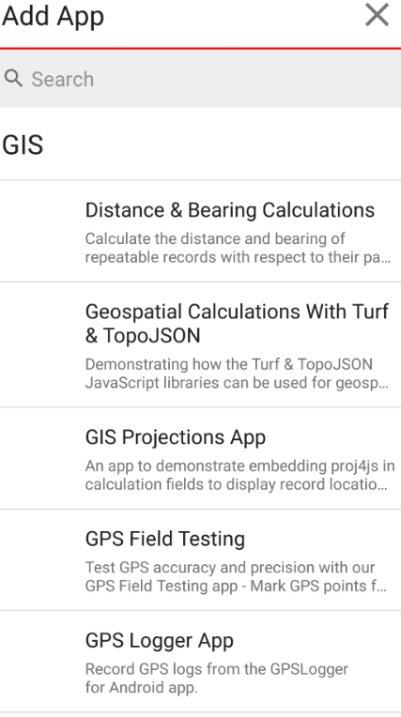

**Data filtering and UI settings.**  
Depending on user’s preference, users can also choose how they want the map to be displayed by clicking the small button underneath the search function. (Picture 1).

By tapping the drop-down settings (3 vertical dots), it is shown with 5 options; Synchronize Data, which updates the currently collected data to the database. Place Search, which user can navigate to the specific part of the GUI map by entering the location, (they can also get the current location by clicking the GPS function button on the bottom right). List View / Map view, where users can view all of their collected data through the table list view or directly on the map (2nd photo and the 3rd photo. Record Filter, which filters records with keywords and finally, settings with more general and advanced settings of the application as a whole.

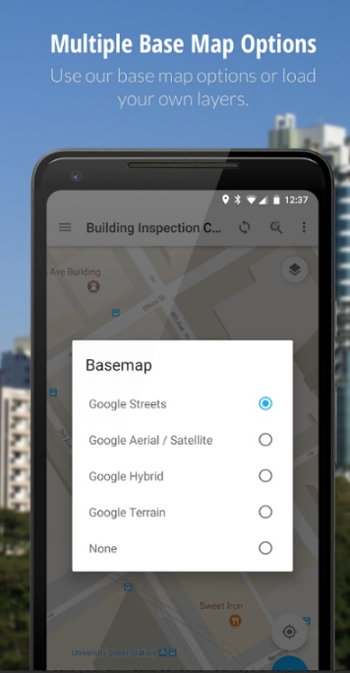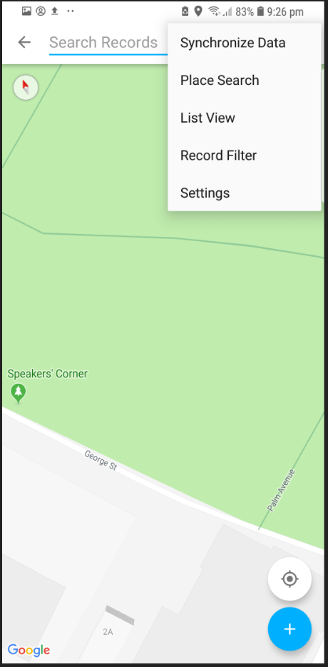 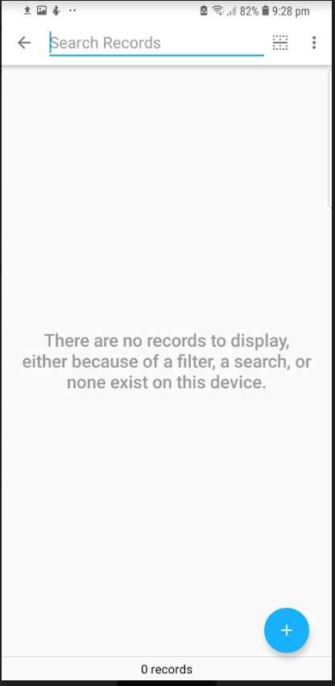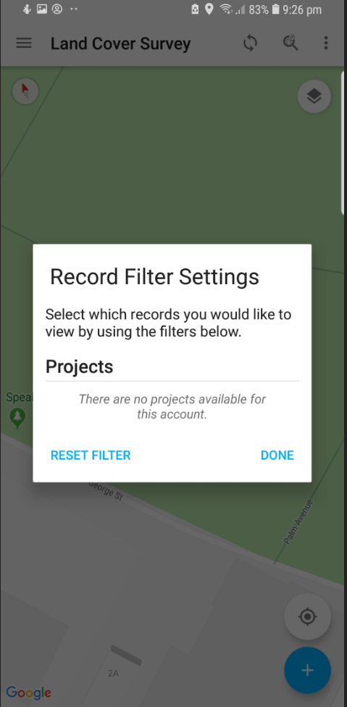

**Gathering and Managing data**

Users can easily input data using the user friendly UI. Firstly they select the location of the data, this can be done in two ways, either manually inputting the latitude and the longitude co-ordinate (2nd photo), or it could be done with the GPS by grabbing the current user’s location (4th photo).

Then depending on which ‘application form’ you are using to collect data, it will ask about different information of the data inputted. In example, custom projections application will only ask for ‘projection name’ -> ‘x-value’ -> ‘y-value’, however, in the landcover application it will ask for ‘Land cover type’ -> ‘then its related information’ and so on.

Users can also provide visual information about the data, such as capturing a photo or video and submitting the data as a whole. Users can use Fulcrum and gather data offline, meaning that, if the internet connection to the central database has dropped, your collected information will be saved into your local storage and will be synchronized when available, instead of losing the data, a specific data record can be generated into a report (seen in 5th photo), however, this functionality requires internet connection.

To analyse the data, user can access the data from a web portal, where they can review and visualize their collected data as an individual or as a group, also, through the web portal, user can build a customized application form where they may create their personalized application for the collection of the data they need.

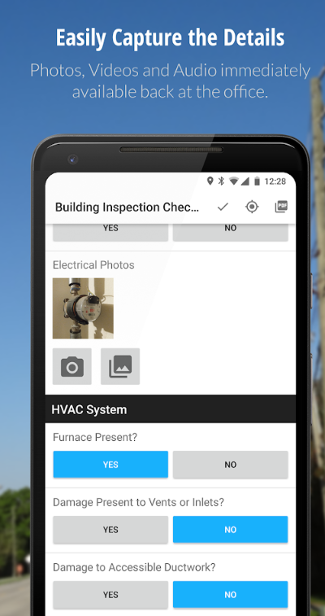 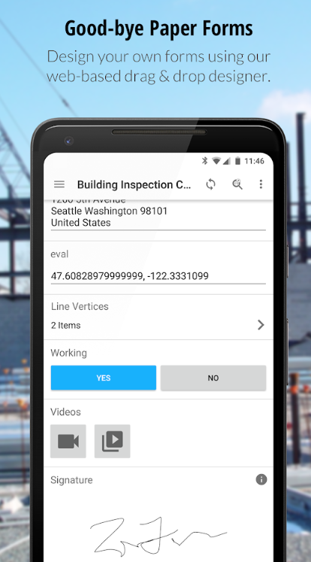 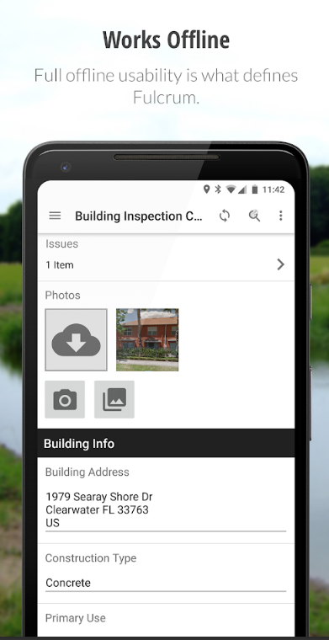

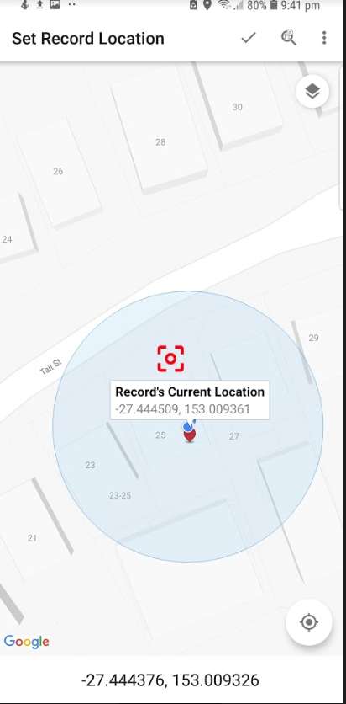 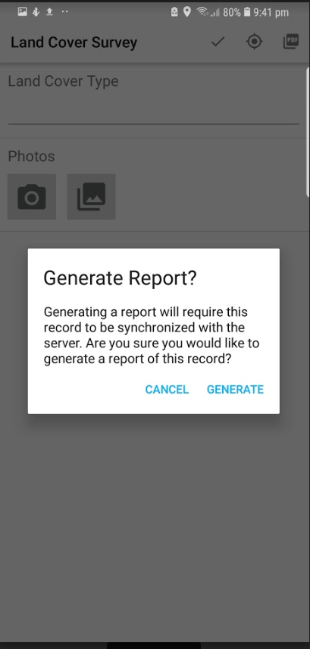 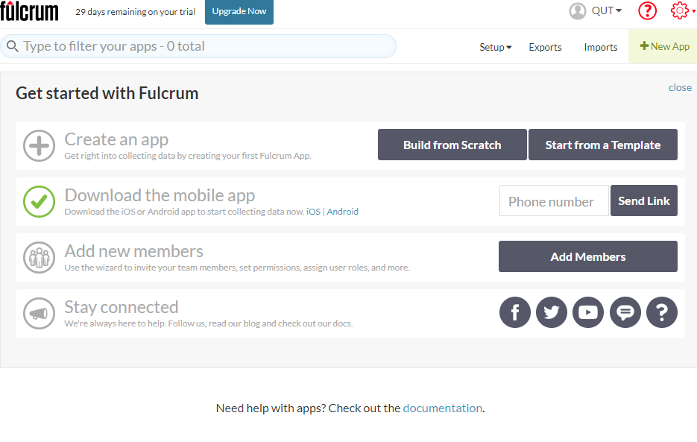

**Positives:**

**Approach –** This applications approaches the main problem many data collectors face, fixed data inputs and loss of data due to demand of internet while using this application.

**Features and functionality –** The key features of this application, would be the ability to work offline, preventing data loss between poor internet connections and variety of application forms to choose from many industries and having the ability to create your own personalized forms to work with, it provides users with great flexibility.

It allows group collaborations and data visualisations with the use of web portals.

**General UI design –** The UI design is very user friendly, everything is laid out in a nice tabular format, with an appropriate sizes for widgets, labels, buttons and forms.

**Page navigation –** The page navigations of this application was very pleasing, having all of the features in a tabular format, it was easy to navigate.

**Negatives -**

**Features and functionality –** The only negatives about this application features would be that after using the 30 day trial of this mobile application, you need to pay a subscription fee.

**Page navigation –** At first, it is difficult to understand how to operate this application, as there are no instructions on using the application, it requires users to play around with the application until they understand the core functionalities and how it works.

**Review**

From reviewing ‘*Fulcrum*’ it would be very useful if we could implement these features

+ Ability to work offline.

+ Instead of inputting each data information one by one, have a quick side bar that allows you to tap on the map and choose recent data type which pre-fills the information.

+ Ability to add visual information into the dataset such as photos.

+ Being able to tap on the map to choose the data location, instead of manually inputting the latitude and the longitude

+ Ability to export every dataset on the map into a pdf or csv file through downloading or email.

**2. ArcGIS**

<https://play.google.com/store/apps/details?id=com.esri.explorer>

<https://play.google.com/store/apps/details?id=com.esri.arcgis.collector>

**General Overview and Starting *ArcGIS***

Esri, the company of ArcGIS, has separated distinct ArcGIS applications which has different intended uses. (Collector, Surveyor, Explorer, Navigator, as seen in 1st picture below). ‘Collector for ArcGIS’ is the application used for collecting data, which is the most related functionality to our application ‘Geo App’.

When first launching the application, the user is greeted with a home page, which consists of ArcGIS’s login page which automatically synchornises your previous collections on your account or just utilizing the application without logging in (2nd photo). Continuing on, users can choose from 7 different types of maps (which is arranged in a tabular format), that changes the way map is displayed and depending on the chosen map, the data that can be collected is also changed, and users are welcome to go back and change their map selection anytime (3rd picture).

Finally, users can operate their data collection while disconnected from internet by downloading the map to your local device (similar to using offline google map navigation), and continue to work on their task without limitations.

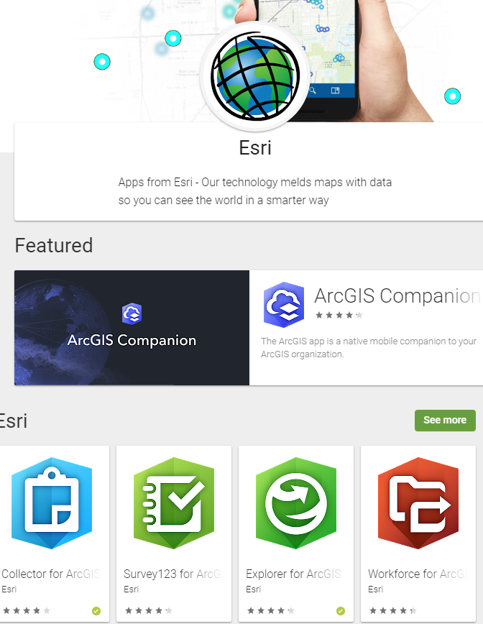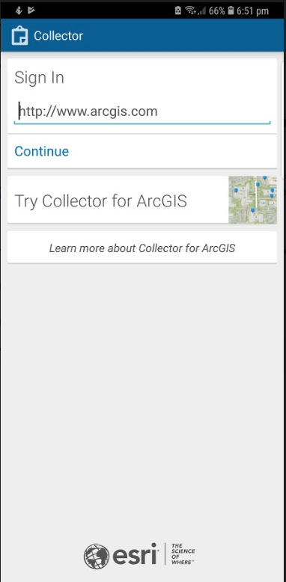 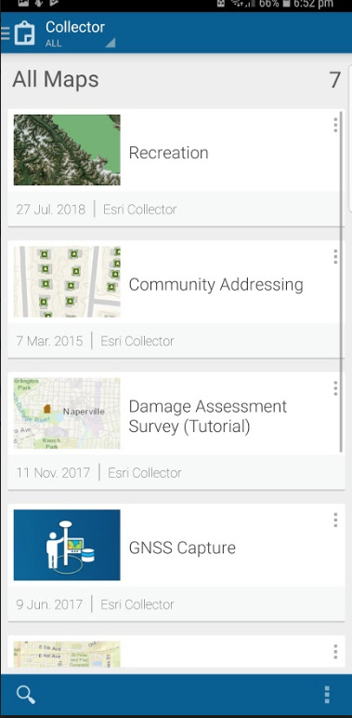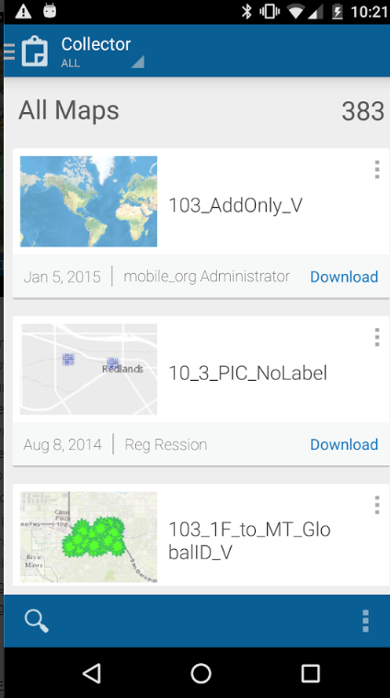

**Gathering data and general UI**

The general UI is good and easy to use, however, one UI design I personally disliked was the navigation bar of the data map page (1st photo), when trying to use the application for data collecting, most of the pop-ups will come up from the bottom (2nd photo), and sometimes it will transfer the user to a new page which demands users to navigate from the top left, which I found somewhat irritating.

Starting from the left of the navigation bar, first is the GPS function, it is used to **toggle** GPS on and off, if the white rectangular box appears above the navigation bar (1st photo) it means the GPS is active, users can then click the white box to view the GPS status (3rd photo), such as horizontal and vertical accuracy, frequency of the GPS update and etc. The second function of the navigation bar is used to record new data onto the map (4th photo), it will prompt the user with the available data type that can be recorded (which is different depending on which map user first chose), in this case it provides users with ‘facilities’, ‘trails’ and ‘Recreational Area’. Once user decides which data type the want to record, it will ask users for more information, where they can input description of the data, physical quality of the data, visual data (photos, videos) and the date it was recorded (5th photo). After user has recorded the data, it can then be visually seen in the map indicated by friendly icons (1st and 6th photo) that can be tapped on for more information. Finally, the search filter and the bookmark function, where users can search through their data with given keyword and bookmarking desired location.

Also, there are 3 other applications which can be integrated with ‘Collector for ArcGIS’ that provides additional functions, such as producing optimal path routes (navigator for ArcGIS) and ‘Explorer for ArcGIS’ which allows you to mark up the map that allows users to input multiple information on a property (e.g. building, house, etc.).

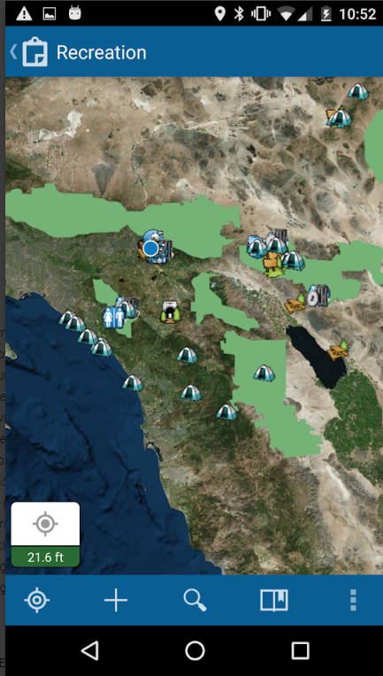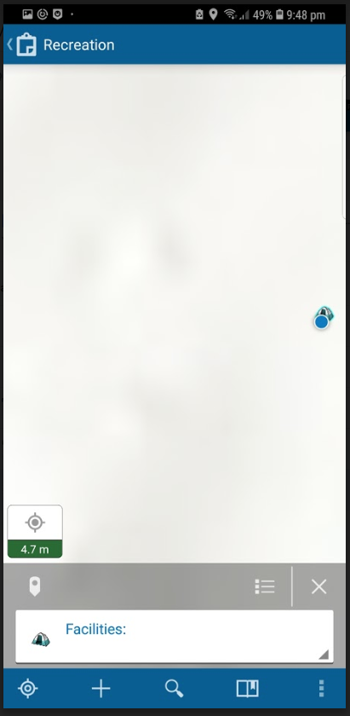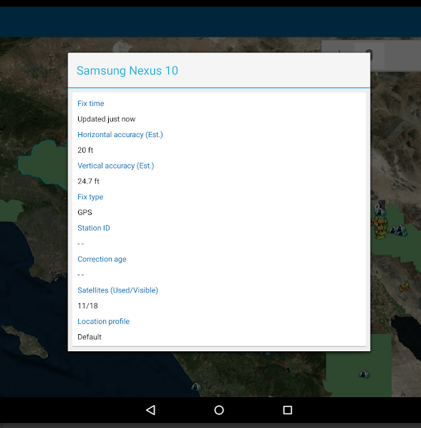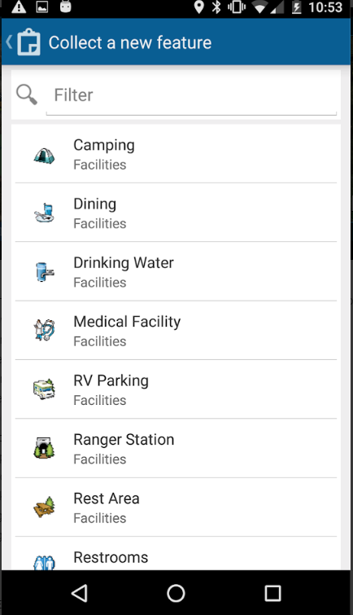 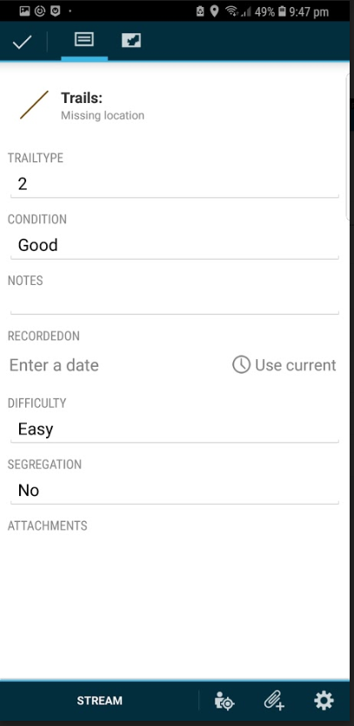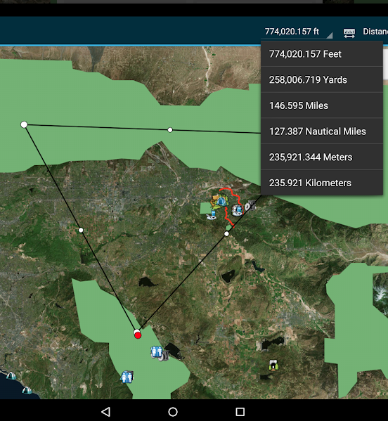

**Positives and negatives of ArcGIS**

**Features and functionality –** There are many functionalities and features included in the ArcGIS, users can work offline by pre-downloading the map data, users can collect, view data in a user friendly UI, use other ArcGIS application, such as ‘Navigator for ArcGIS’, ‘Explorer for ArcGIS’ or Workforce for ArcGIS’ to utilise the data in flexible and multiple ways alone or collaboratively.

The downside of ArcGIS would be that, to experience the maximum potential, users are required to download 4 separate ArcGIS applications and going back and forward between those applications.

**General UI design –** General UI design is user friendly, all UI components are laid in a tabular format with appropriate sizes and good colour contrast, which is pleasant on the eyes.

One great UI feature to be mentioned would be the icon for each individual data, when the data is created, it also produces an user friendly icon on the location of the map, when clicked, directing the user to more descriptive information about the dataset.

**Page navigation –** The page navigations of this application was acceptable, when it comes to collecting data, the navigation bar is fixed to the bottom, however when proceeding further, pop-ups and other inputs are mostly laid on the top making it frustrating for user to operate gracefully.

**Review**

From reviewing ‘*ArcGIS*’ it would be very useful if we could implement these features

+ Making short-cuts of popular data, which in Geo-App it would be; trees, bins, Wi-fi, etc. that would pre-filling redundant information about the data and producing a user friendly icon, providing convenience.

+ Being able to view and click on every dataset on the map, when clicked, providing users with descriptive information.

+ Application as a whole, unlike ArcGIS where it requires user to download multiple application for viewing, collecting, navigating data.

+ Page navigation to be consistent, top left to bottom right, unlike ArcGIS where it is top left to bottom right in the main page, bottom to top in map page, top to bottom in data input page.

+ Multiple pages, ArcGIS crammed all the functionality into one page which was map / data collection page. Instead, we Geo App could have multiple pages for separate uses into a clickable dropdown bar(e.g. collecting data, viewing data, managing data (export / import), settings) and a nav-bar for more direct functions (e.g. in collecting data page, adding data, deleting data, GPS status, etc.)